Dynamo DB

Databases are available in 3 different forms:

1. Unstructured
2. Semi Structured
3. Structured

Unstructured Data:

1. A data model that either does not have a pre-defined data model or is not organized in a pre-defined manner.
2. ‘Dynamo DB’ is an example for Unstructured Data.
3. Around 80% of the data available on the internet is Unstructured Data.
4. Unstructured Data is typically ‘text heavy’, but may contain data such as dates, numbers and facts as well.
5. Examples include: email messages, word processing documents, videos, photos, audio files presentation web pages.

Semi-Structured Data:

1. Semi-Structured Data is information that does not reside in a relational DB.
2. But it has some organizational properties which makes it easier to analyze.
3. Example: XML, JSON

Structured Data:

1. Structured Data refers to information with a high degree of organization.
2. All data which can be stored in DB SQL in the form of tables(rows and columns).
3. SQL can be applied on the tables for DBMS operations.

Sample Dynamo DB Table:

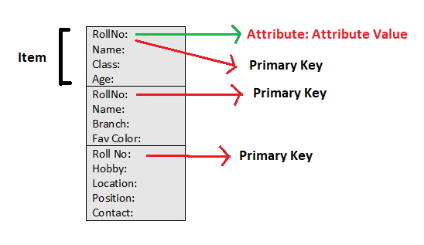

1. A table is a collection of data items.
2. Like all other databases, Dynamo DB stores data in tables.
3. Each table contains multiple items.
4. An item is a group of attributes, that is uniquely identifiable among all the other items.
5. An item consist of a primary or composite key and a flexible number of attributes.
6. **IMP**: Aggregate size of an ‘item’ cannot exceed 400KB including all keys.

IQ: How to add data of an item which exceeds 400kb?

Sol: Store the data in S3 bucket, and generate the url of the object and add that url as an attribute in the item.

Global Tables:

Global tables replicate your DynamoDB tables automatically across your choice of AWS Regions. Global tables eliminate the difficult work of replicating data between Regions and resolving update conflicts, enabling you to focus on your application's business logic.

**Dynamo DB**

**\*SCU🡪Strongly Consistent Unit**

**\*\*ECU 🡪Eventually Consistent Unit**

|  |  |  |
| --- | --- | --- |
| **Read Capacity Unit(RCU)** | **Write Capacity Unit(WCU)** | **Transactional** |
| 1 RCU = 1 SCU/sec or 2 ECU/sec (for an item up to 4KB in size)  Example: 1 SCU = 4KB(in case of SCU)  1 ECU = 8KB(in case of ECU)  If 1 SCU costs 10rs, than 1 ECU costs 10rs with double data benefit.  ECU is faster than SCU.  **But ECU has its drawbacks.**   * In case of ECU, data will be withdrawn before new updates were being affected. * In case of SCU, data will be withdrawn a few seconds late but fully updated data will be retrieved. | 1 WCU = 1KB of data  1000 WCU = 1000KB of data  One WCU represents one write per second for an item up to 1kb in size.  If you need to write an item that is larger than 1 kb, Dynamo DB will need to consume additional WCUs. | ConditionCheck  These actions can target up to 25 distinct items in one or more DynamoDB tables within the same AWS account and in the same Region.  The aggregate size of the items in the transaction cannot exceed 4 MB. The actions are completed atomically so that either all of them succeed or none of them succeeds.  You can't target the same item with multiple operations within the same transaction. For example, you can't perform a ‘ConditionCheck’ and also an ‘Update action’ on the same item in the same transaction. |
| If you need to read an item that is larger than 4KB,  Dynamo DB will need to consume additional RCUs. | There is no SCU or ECU concept in WCU. |  |
| The total number of RCUs required depends on the item size and weather you want SCU or ECU. | The total number of WCU’s required depends on the ‘item’ size. | You can add the following types of actions to a transaction:   * Put * Update * Delete * ConditionCheck |
| **Billing (RCU * cost):**  To read data of 2kb:  In case of SCU = 1RCU(4kb per RCU limit) is consumed  In case of ECU = 1RCU(8kb per RCU limit) is consumed  To read data of 7kb:  In case of SCU = 2RCU(4kb + 3kb) is consumed  In case of ECU = 1RCU(7kb) is consumed  To read data of 1000kb:  In case of SCU = 1000kb/4kb = 250RCU  In case of ECU = 1000kb/8kb = 125RCU | Dynamo DB is preferred to use in the applications which has frequent read operations and few write operations.  Ex: **Gaming or Web Applications**. |  |

**Dynamo DB Billing:**

1. In any DB, read operations are cheaper than write operations. So in Dynamo DB.
2. Charges for read and writes are applicable on hourly basis.
3. Even if you are not reading or writing any data from the Dynamo DB, still minimal amount of charges are applied for using the DB.
4. If S3 buckets are used, then charges will be incurred.
5. Internet Data Transfer ( if data is transferred outside the region), charges will be applied.
6. In case of free tier accounts, up to 25 SCUs and 25 ECUs per month are free.

Dynamo DB limits:

1. Dynamo DB can do 10,000 WCU/sec and 10,000 RCU/sec per table.
2. More than these capacities needed, than you have to request AWS.
3. You can create up to 256 tables per account per region.
4. No size limit on any table.

*******************************************************************************

Next Session: Hands On Lab